**1) (a) What is an interchange format?**

Format of files which could be shared between users

**(b) Give three examples of interchange formats**

GIF ( Graphic Interchange Format)

PDF (Portable Document Format)

JPEG( Joint Photographic Experts Group)

**(c) What is the signature of a PGM format. Give two examples of the signature.**

The PGM signature show if the PGM file is in ASCII format or in Binary. The two corresponding signatures are P2 for ASCII and P5 for binary.

**(d) What is patterning in printing?**

A lot of the modern printers are unable to print individual pixels due to how small they are so instead they take the best approximation and print a certain pattern of a certain size.

**(e) Explain the principle and operation of error diffusion for printing.** If there is an error in printing, then instead of printing that error is one space where it will be very noticeable it instead gets printed over a larger are or “diffused” so that it become much less noticeable. This method works by utilizing the pixels ahead of the error and adding on some of the value to those pixels.

2) Given Info:

Photosets 5 x 5 microns

Spacing 1 micron

Circuit Board 60mm x 60mm --- X

Smallest feature 0.4mm

Smallest defect 6x6 pixels

Focal length multiples of 25mm, 35mm, 50mm

Camera Resolutions are multiples of 256x256

Resolution up to 2,048x2,048

Focal distance between 200mm and 500mm

Solution:

Resolution = 6(Object size/smallest feature)

6(60/0.4) = 900 pixels

Since that is not a multiple of 256x256 then we have to move up to 1,024x1,024

Image plane size = (size of photosites + spacing) x (Resolution)

(0.005+0.001)x1024 = 6.144 mm

Board to Lens Distance = (Focal Length x Object Size) / image Size

(25x60)/6.144 = 244.14mm

(35x60)/6.144 = 341.8mm

(50x60)/6.144 = 488.28mm

**Minimum Camera Resolution is 1024x1024 and Focal length can be 25mm, 35mm or 50mm.**

3)

The storage saving has an exponential growth curve and can be represented by the equation 2^(b-c).

The code for this section is relatively simple and consists of simply loading the image, doing the math and printing the image.

1 img = imread("apple.JPG"); %reads image

2 imgN = uint8(img/64) * 64;

3 imshow(imgN);

The input is output is

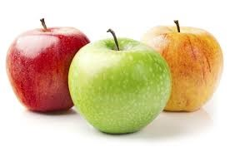 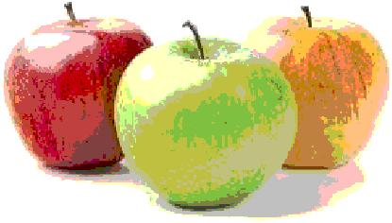

4)

1 img = imread(“IMAGENAME.JPG”); %reads image

2 for height = 1:size(img,1)

3 for width = 1:size(img,2)

4 if img(height,width,1) < 85 || img(height,width,2) > 100 || img(height,width,3) > 100

%RGB if red<85 or greewidth>100 or Blue >100

5 gray = 0.3*img(height,width,1) + 0.59*img(height,width,2) + 0.11*img(height,width,3);

%grayscale to rgb conversion equation

6 img(height,width,:) = [gray gray gray];

%replace the selected pixel with gray

7 end

8 end

9 end

10 imshow(img)

In this case this creates an image of a rose similar to that given in our assignment.

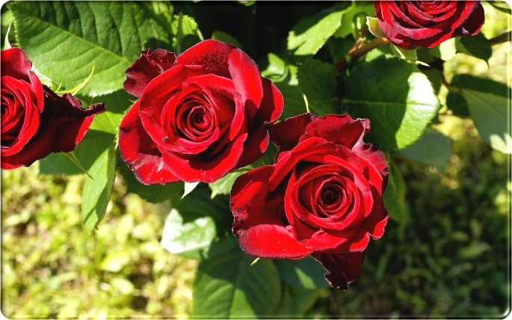 to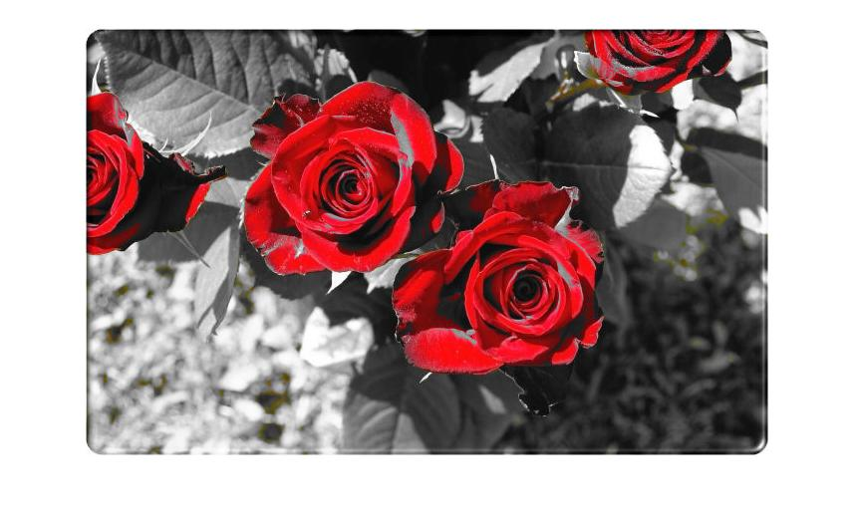

With that in mind if we want to attempt to isolate a different element of a picture, say the sun light shining through the forest canopy we get something like this.

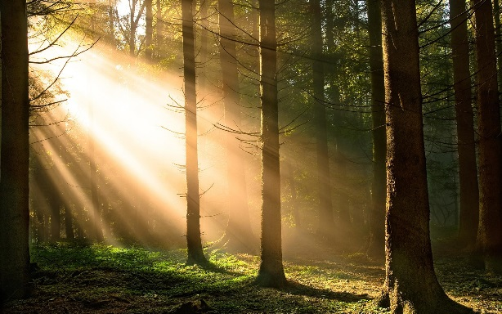 to 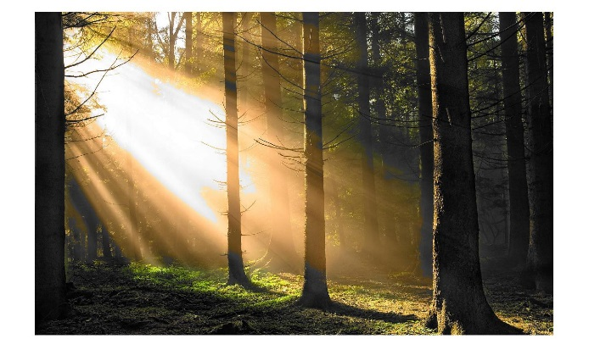

To achieve this we simply changed line 4 of the code to

**4 if img(height,width,1) < 23|| img(height,width,2) < 60|| img(height,width,3) > 180**

Since yellow is a composite color we can see the difficulty in isolating just it. Furthermore if it is isolated too much the picture will loose all vibrancy. As in the image bellow with the following change to line 4.

**4 if img(height,width,1) < 100|| img(height,width,2) < 130|| img(height,width,3) > 200**

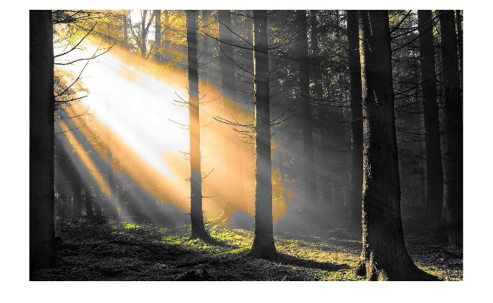

Similar things happen with hues of colors, for example lets use blue and its shades. Here is an image of a lake, if we want to only isolate blue we get this.

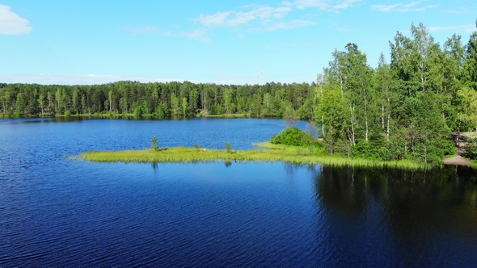 to 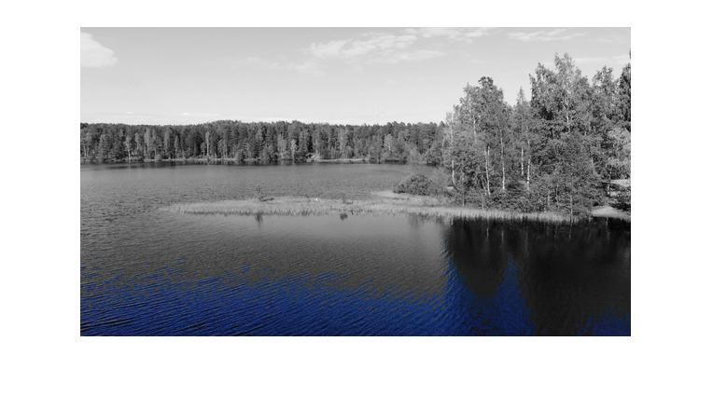

Our line 4 looks like this

**if img(height,width,1) > 60|| img(height,width,2) > 60|| img(height,width,3) < 60**

but if we incorporate all the colors with relatively high thresholds we can get something like this.

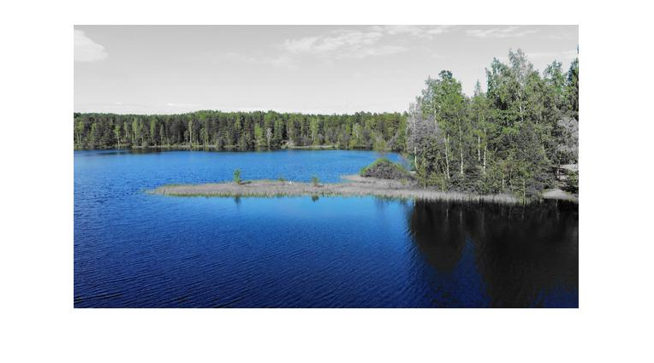

In this case here is our line 4

**if img(height,width,1) > 130|| img(height,width,2) > 200|| img(height,width,3) < 60**

Note that we kept or blue value threshold at the same level, while loosening the bounds for both red and green. This demonstrates that most colors are a complex mix of the RGB values.